RxJS: The Big Picture

-Rx stands for Reactive Extensions API aka Reactive X aka Rx

-API for asynchronous programming with observable streams (the data flows into your app)

-RxJS is the Javascript implementation of the Reactive Extension API

What problems does RxJS solve?

-provides a single API that facilitates and simplifies the processing of data from multiple/ sources

-Many different types of streams of data is processed a little differently in plain JS.

-RxJS helps you deal with these disparate data sources and the multiple ways they might be processed by giving you a single clean API you can use with all of them

-Named observable because the reactive extensions get their conceptual foundation from the observer software development pattern

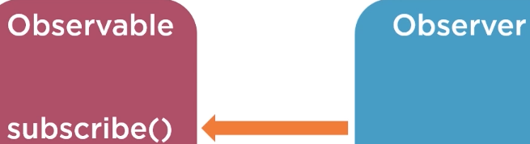

-Observable pushes value to a single observer?

-Register an observer to receive the values from an observable by calling a method on the observable named subscribe

-The observer that should receive the value is passed as a parameter to the subscribe method

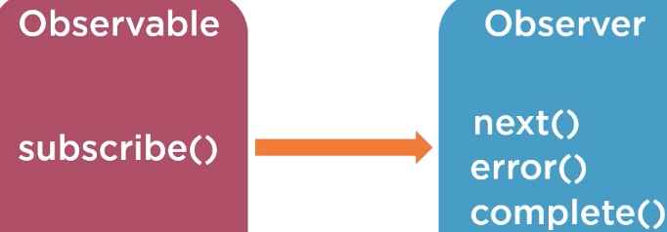

-The observable sends values to the observer by calling methods on the observer object itself

-Once the observer is subscribed to the observable, the first value can be pushed to the observer by calling next

-Operators are functions that manipulate the data produced by an observable and return a new observable

Library

-supplemental pieces of functionality

-solve specific problems but doesn’t dictate the overall architecture of your app

Frameworks

-much larger and prescriptive



-$ is a convention when using RxJS to store observables

-from will create an observable

Subjects: let you produce values for multiple observers

Schedulers: gives fined grained control over when your observables are executed

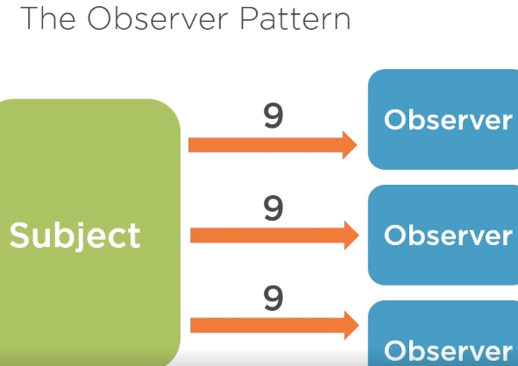

Subjects

-similar to observables

-can push to multiple observers (multicast)

-Observables can only produces values to a single observer (unicast)

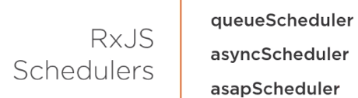

-Observables can be configured with schedulers to control the execution context for the observable

-Only have to worry about schedulers if you want to do something very precise

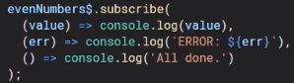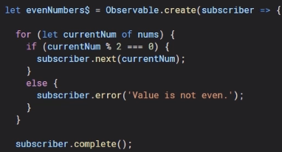

-Observables will never call error and complete

RxJs in Angular: Reactive Development

-Declaring data streams, combining streams, reacting to actions

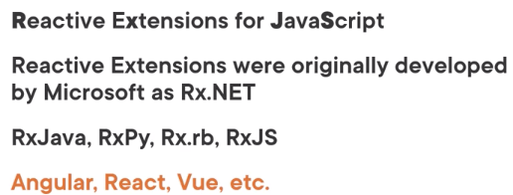

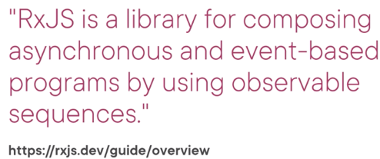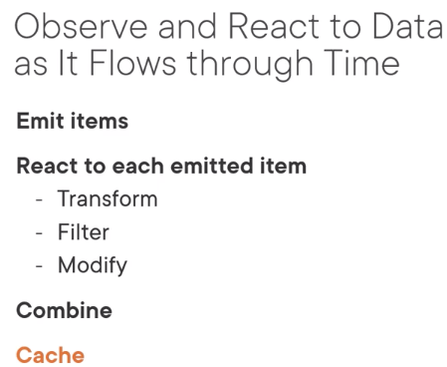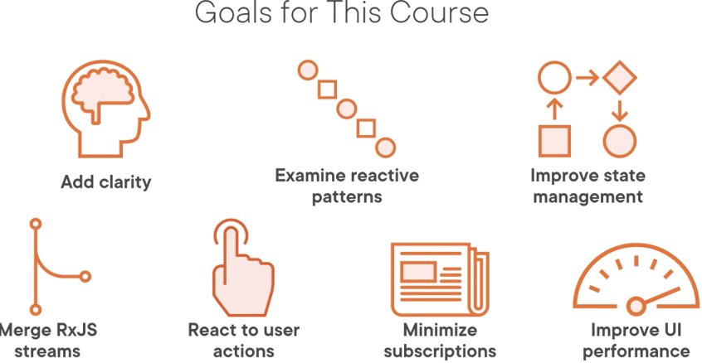

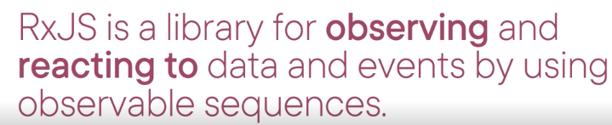

-Cache means retain it in a service to reuse the date without another HTTP request

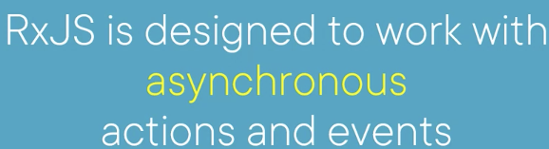

-Angular service requests an HTTP GET request to a back-end server and client code continues and doesn’t have to wait

-Backend server receives the GET request and locates the data (DB) returns an response

-Callback is a function that can be called back after an async operation is complete, but difficult to manage when working with nested async operations

Can only handle a single emission and is not cancelable (promise and async/await)

-Promise is an object that may produce a single value sometime in the future.

-async/await special syntax that allows asynchronous code that looks synchronous.

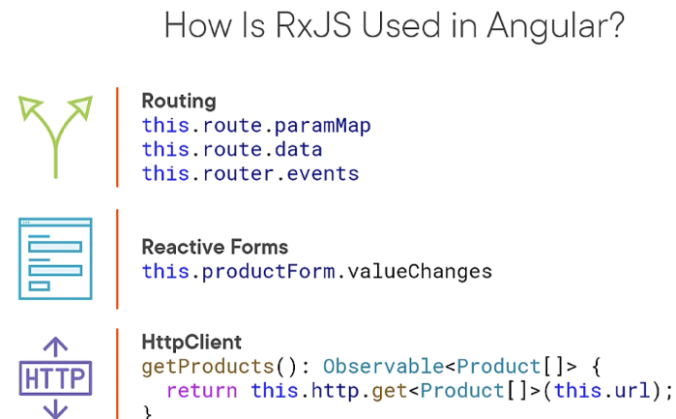

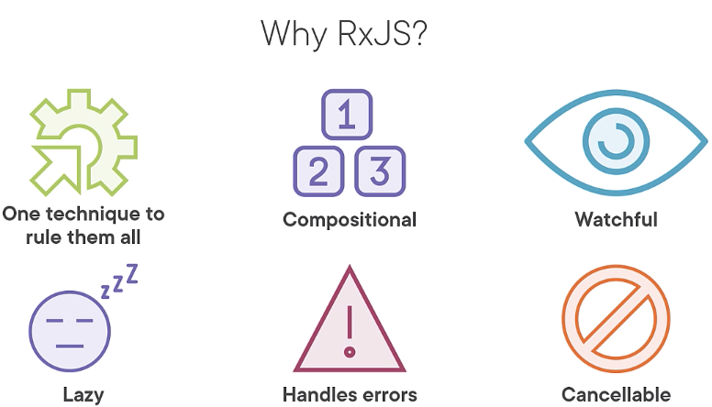

-We work with different data sources using the same technique and operators

-Lazy, evaluation does not start until subscription

Reactive Development

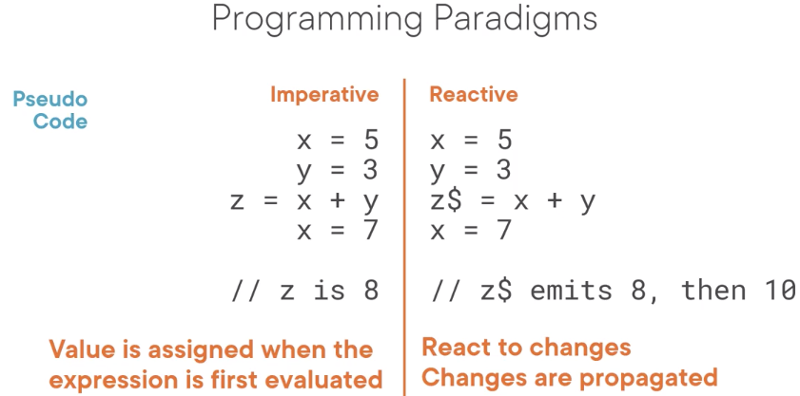

-Like in a shopping cart where we change our quantity to 3

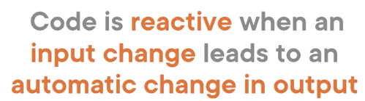What is Reactive Development

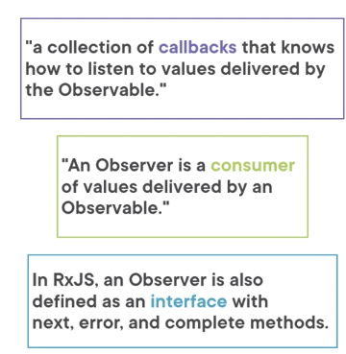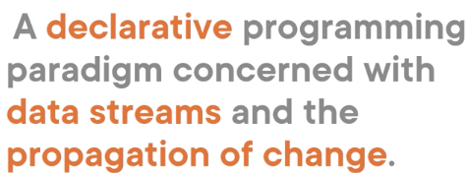

RxJS Terms and Syntax

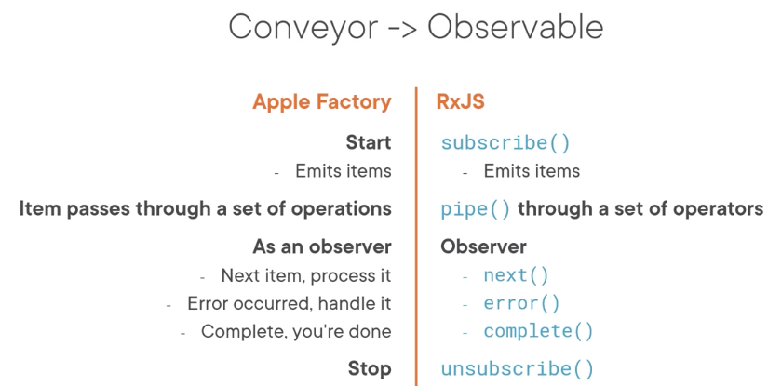

-Apples on the conveyor are observable and I am the observer

-An observer is an object that observes and responds to notifications specified as methods

-So the observable emits notifications and associated values, and it’s the observer that responds to those notifications and consumes those values

Subscriber

-implements the observer interface

-Inside RxJS, each observer is converted to a subscriber

-is rarely used except within RxJS, normally use observer

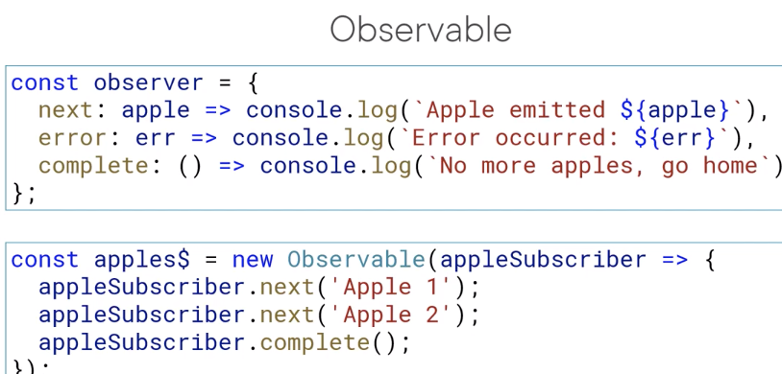

-Handles three types of notification specified as methods

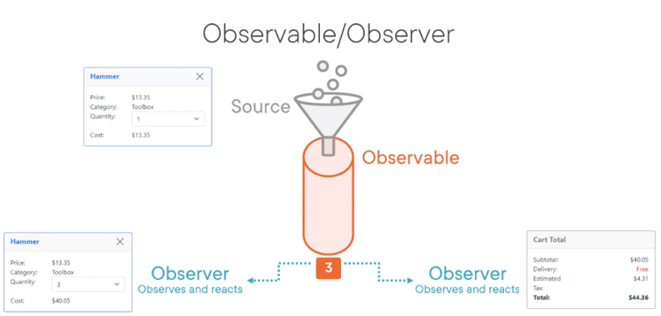

Observable

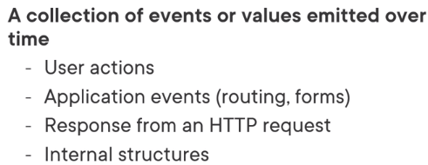

-Think of it as a conveyor collecting and emitting items to an observer

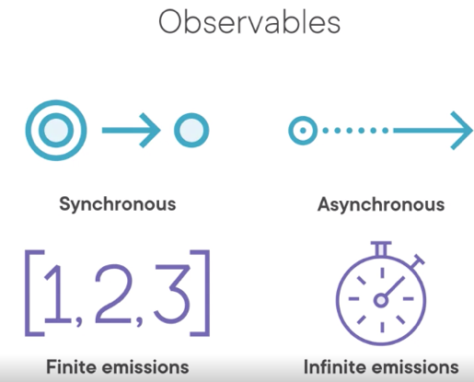

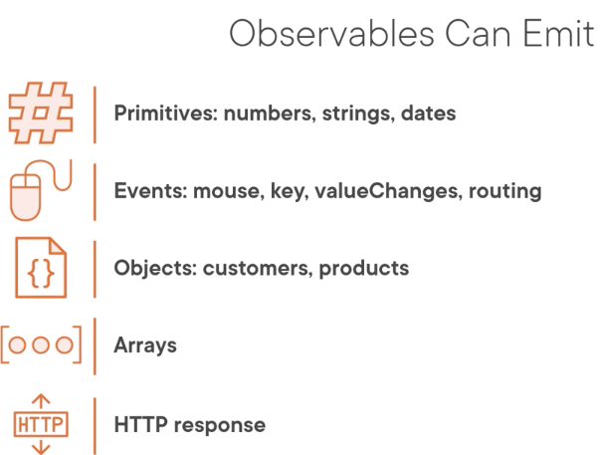

-Observables can by synchronous, meaning the items are emitted immediately and in sequence

Hot: Observables starts emitting items even with no subscriber

Cold: Observables waits for a subscriber

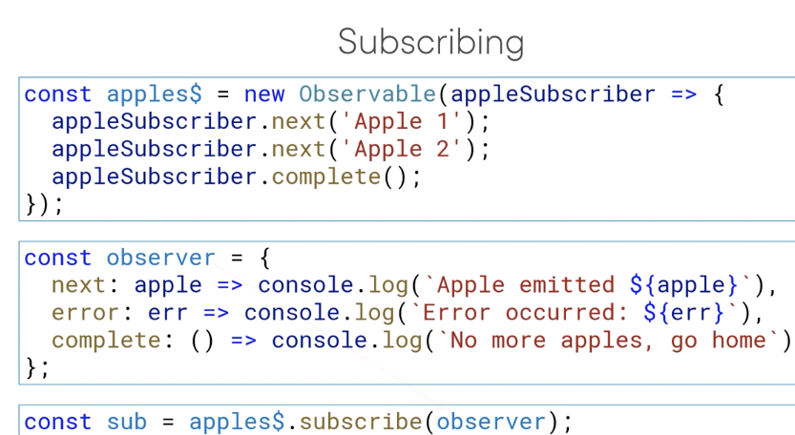

-Observer think of set of callbacks

-Observable think of collections of items emitted over time

Shortcut

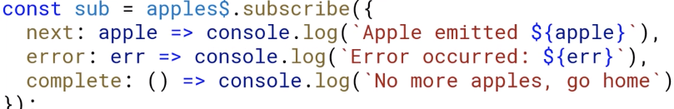

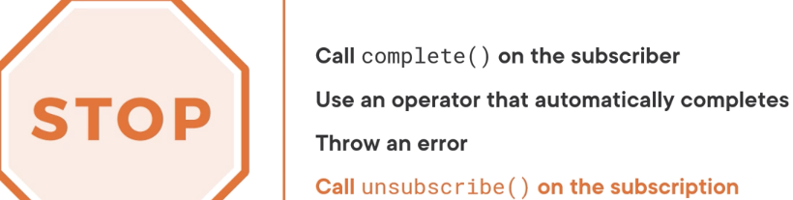

-Unsubscribing does not call the observer’s complete()

-Properly unsubscribing from each Observable helps avoid memory leaks

Creating an Observable



-From is useful for creating an observable from any data

-… is called Spread operator and it spreads the element of the array

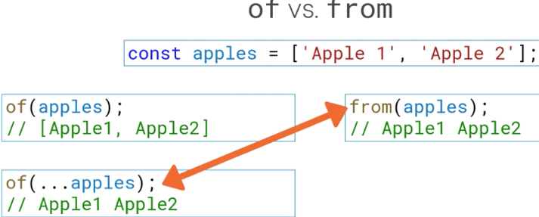-of/from automatically emit a complete notification and unsubscribe

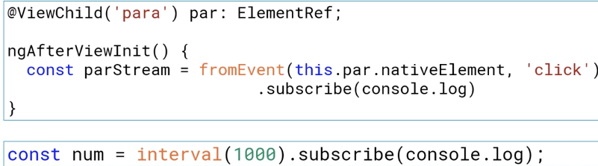

-fromEvent creates an observable from any document, object, model or DOM

-interval creates an observable that emits a sequential number at a defined interval (1000ms)

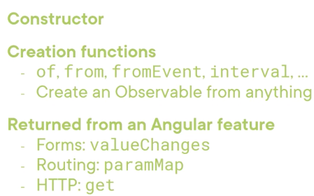

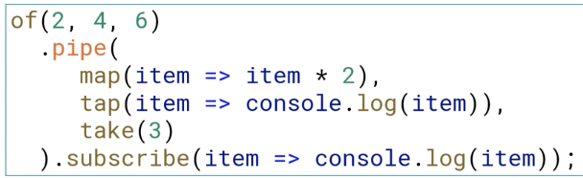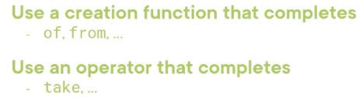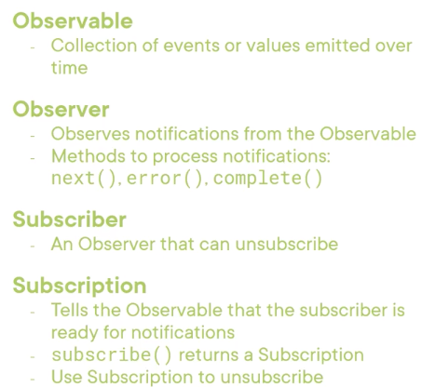

Operators

-is a function

-used to transform and manipulate emitted items

-apply it in sequence using Observab’s pipe method

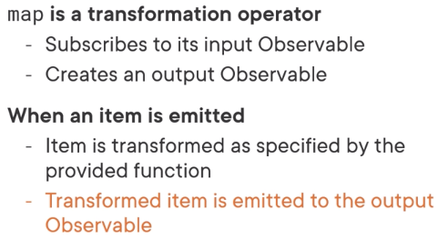

-A function performs a side effect if it changes any state that does not affect its return value

Ex. using tap to increment a counter or set a boolean

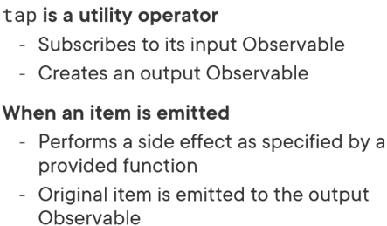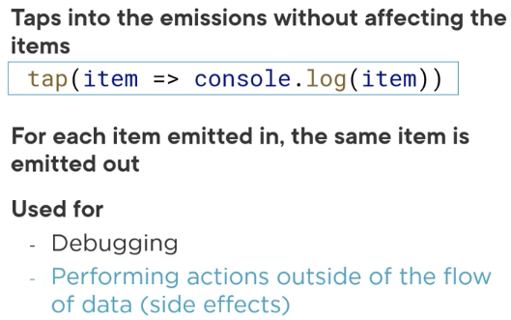

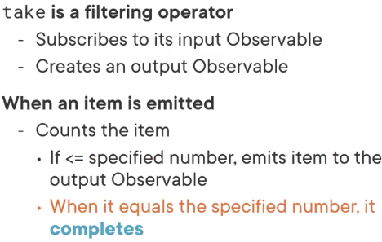

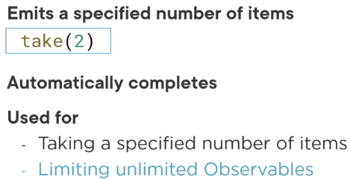

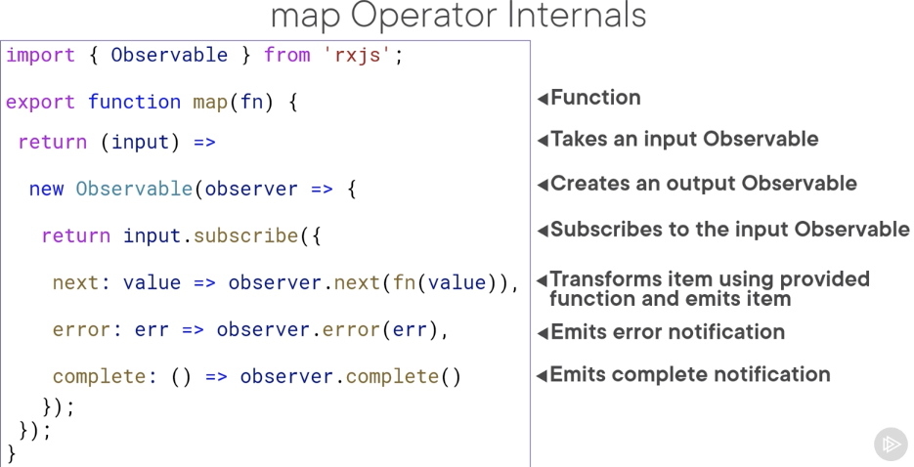

-Main point is operator takes in an input observable, subscribe to it, creates an output observable and emits items and notification to that output observable

-many of us learned procedural patterns for retrieving data, now we will learn Reactive

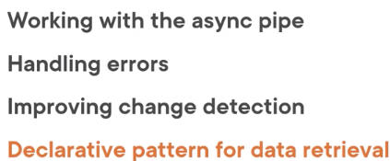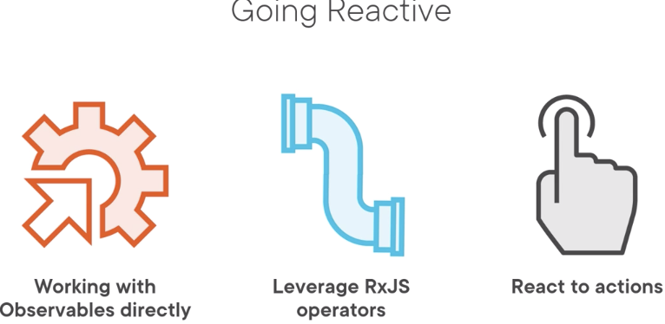

RxJS features: catchError, EMPTY, throwError

Async Pipe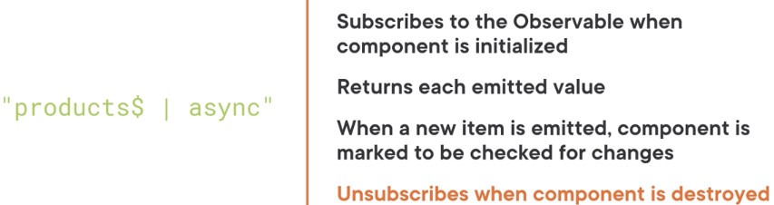

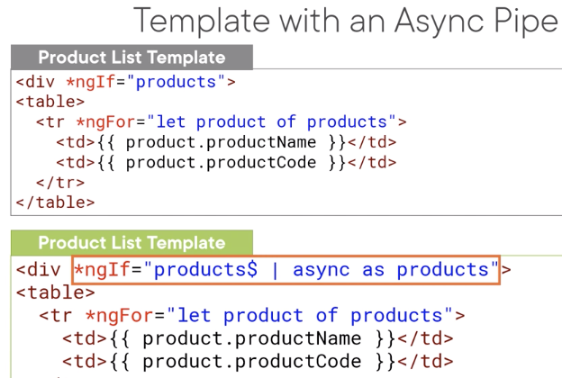

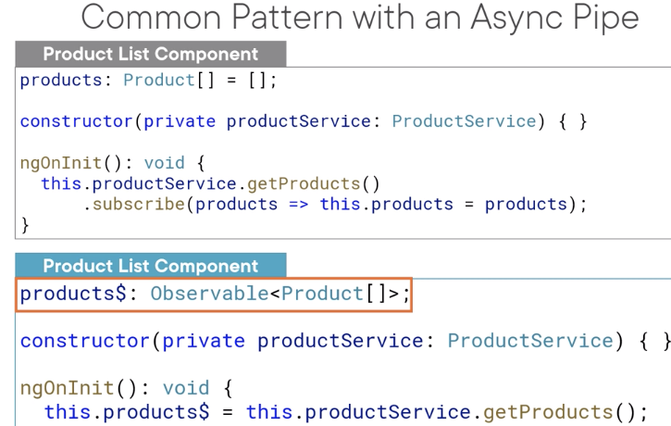

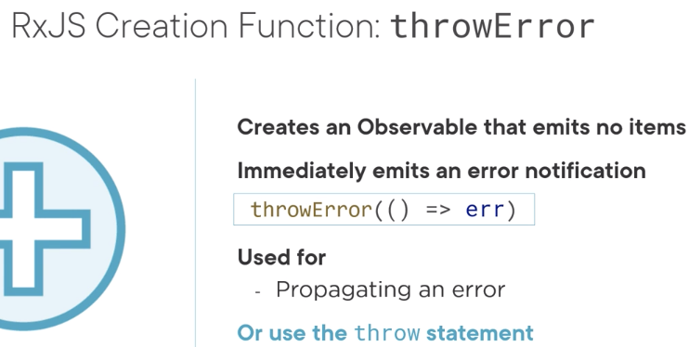

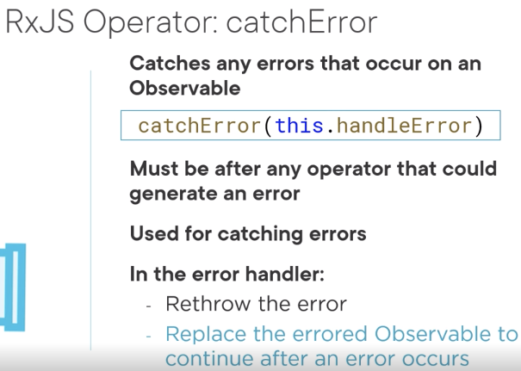

-Can use JS throw statement instead of throwError()

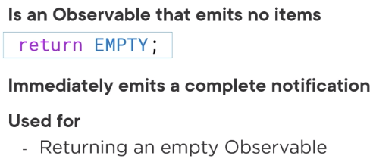

-EMPTY is a constant we can use to replace an errored observable with a valid but empty observable

-emits no items and immediately completes

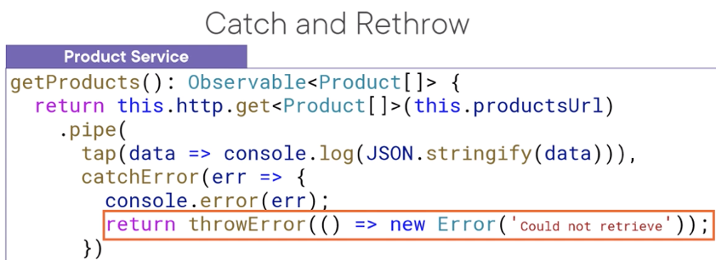Error Handling Strategies

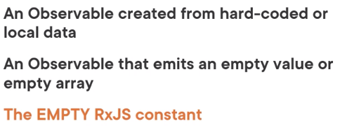



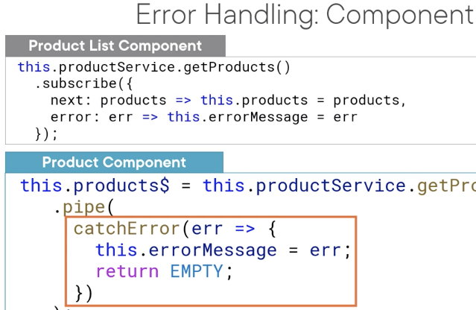

-Bottom part is how we do an Reactive approach since we don’t have subscribe method anymore

-We don’t want to rethrow from our component because the error will propagate to our template, so return an EMPTY observable

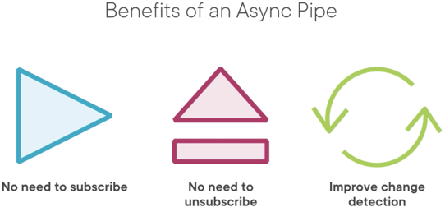

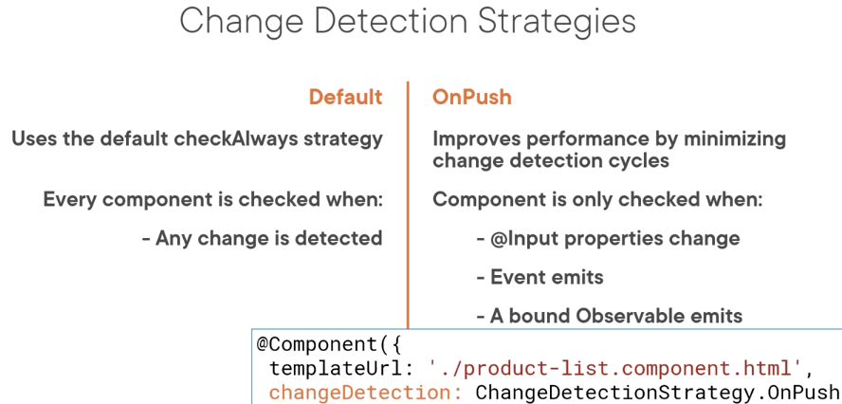

-Angular uses change detection to track changes to app data so that it knows when to update the UI

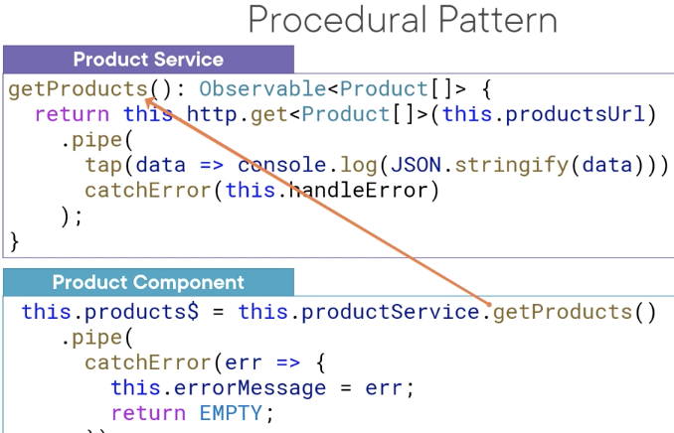

-We have a procedure that calls from our component

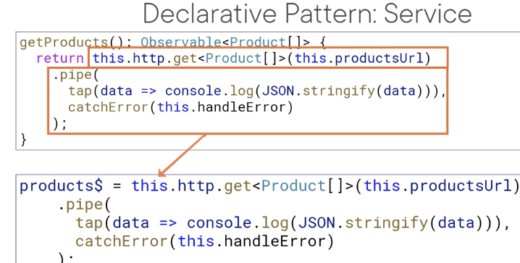

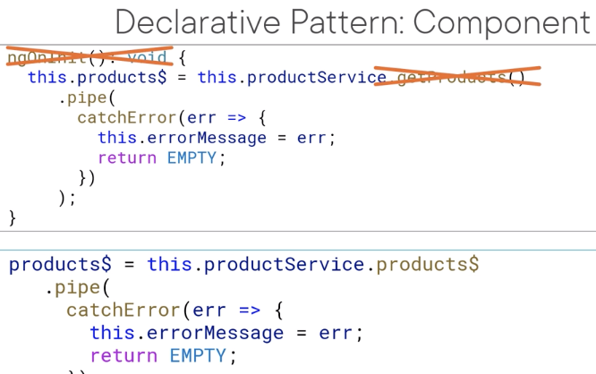

- we declare an observable property and assign it directly to HTTP GET

-Called declarative because each observable are a declared property instead of part of a method

-We work with observables directly instead of calling methods that return observables

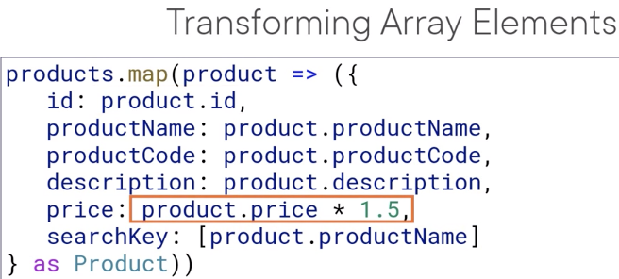

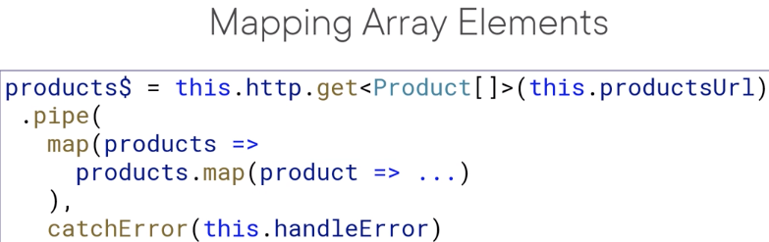

-HHTP will return an observable that has the shape of < >

-We define properties for the desired new product shape and set the value of each product using values from the original retrieved product as needed

-To ensure we keep things strongly typed, we add as Product to type the object literal

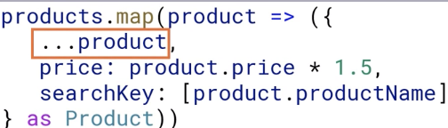

-Use the spread operator as a shortcut

Note: we want an object literal so we add ( ) around our { }

-Must wrap map((products: Product[]) =>

Combining Data Streams

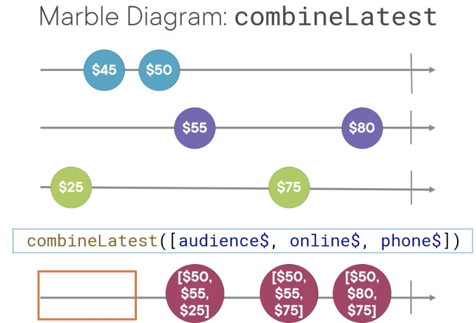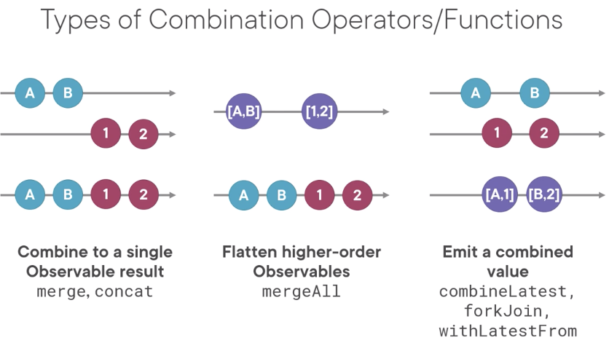

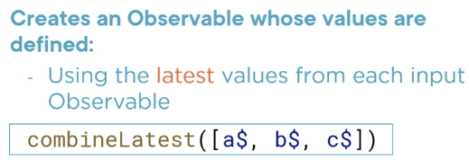

-Does not emit anything until all of the observable have emitted at least one value

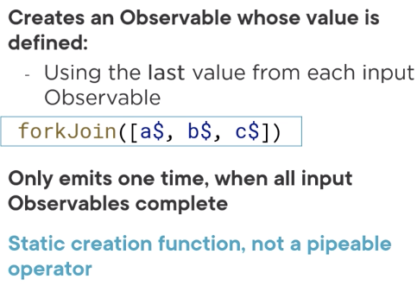

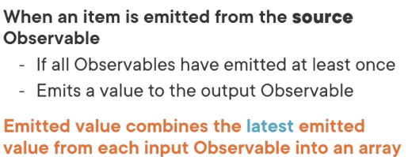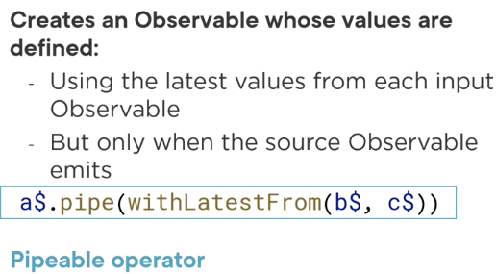

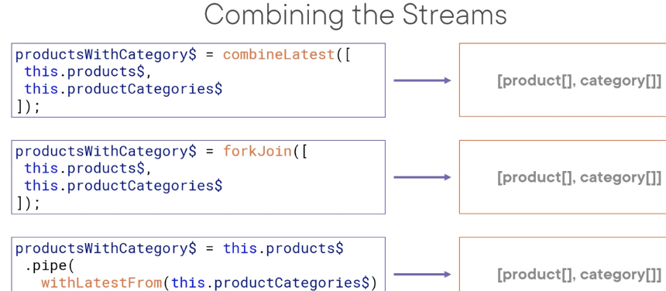

withLatestFrom: if the source observable completes before the other input observables, the result observable will complete without emitting anything

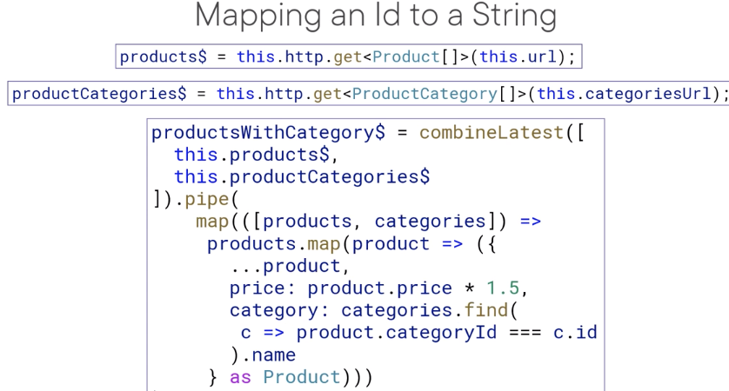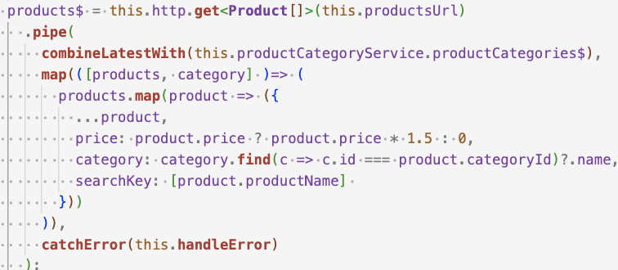

-combineLatest was deprecated

-.pipe( map( (val, index) =>

Reaction to Actions

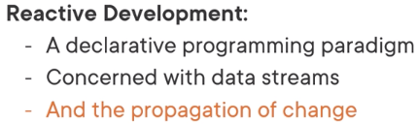

Recap above, RxJS Features: filter, startWith, Subject, BehaviorSubject

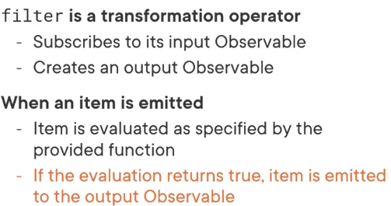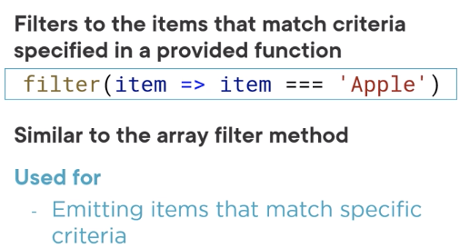



-Don’t need as clause because we aren’t referencing categories$

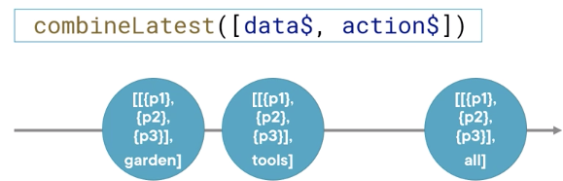

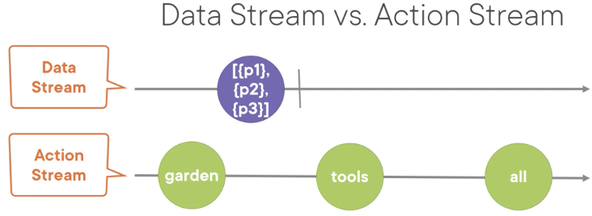

-..Think of HTTP observable as a data stream which will complete and won’t re-execute or react to any changes

-Action stream: alive and keeps emitting new actions until the observable is stopped

-use combineLatest to react to actions, the pipeline (pipe () ) is re-exectuted

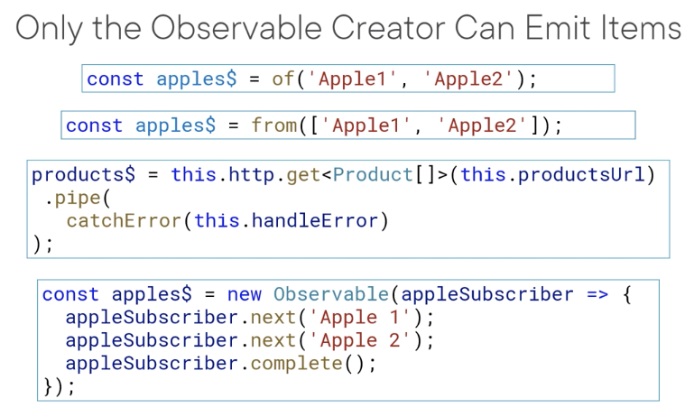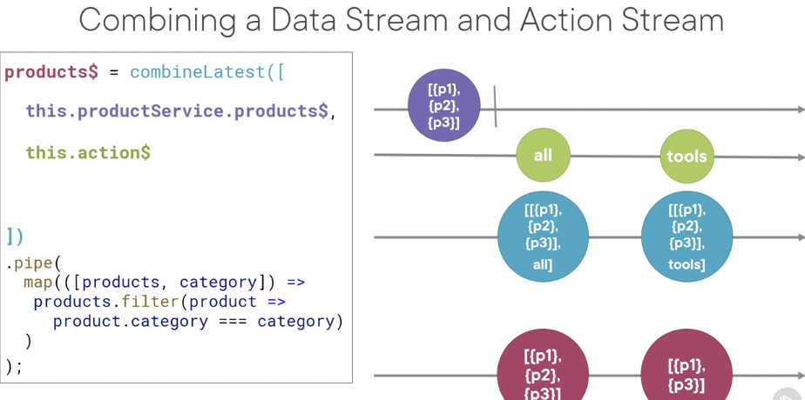

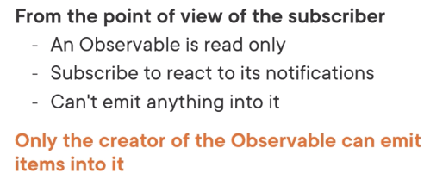

-An observable object doesn’t have an emit method. No next, error or complete

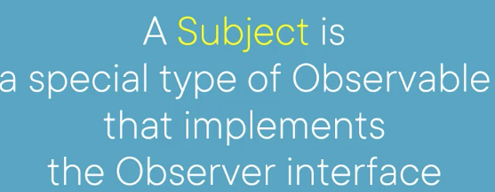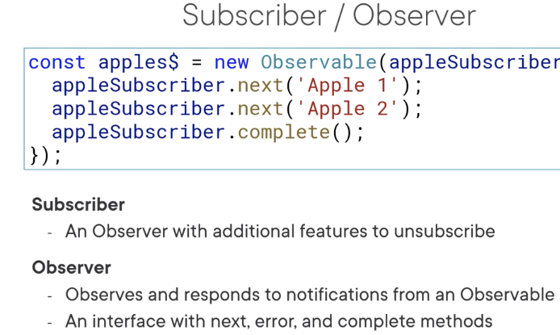

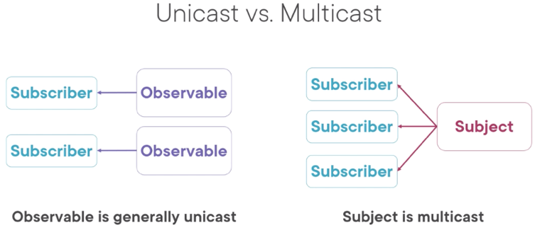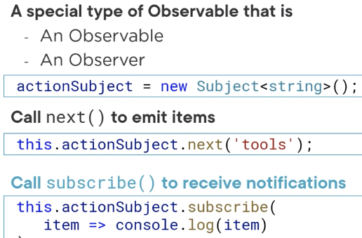

-When there are multiple subscribers, each subscriber gets a new observable

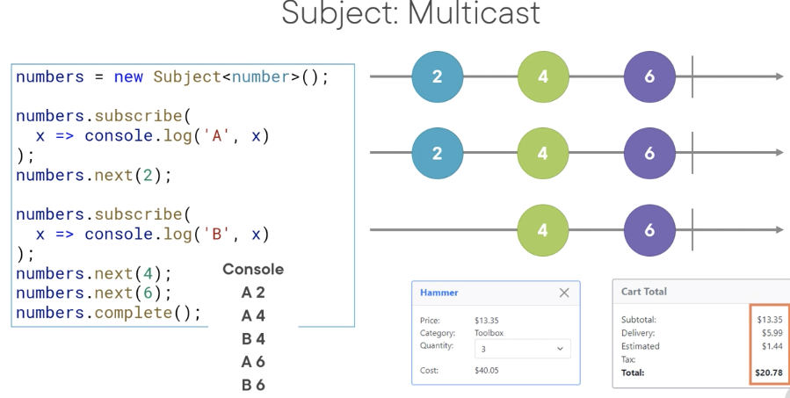

-Example of a real app would you have a late subscriber.

-Shopping cart where each time the quantity is changed, its emitted into the action stream and when user opens the total component which subscribes when the component is initialized

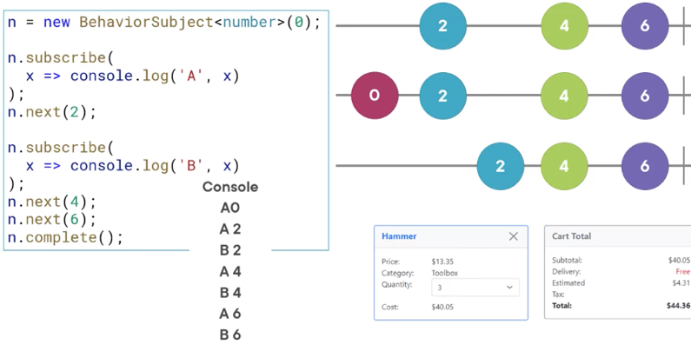

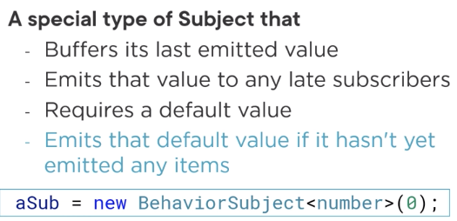

-Behavior subject solves our problem of the late subscriber

-On the first subscribe, the default value is emitted to the subscriber

-The B subscribed late, it will still get the latest emission

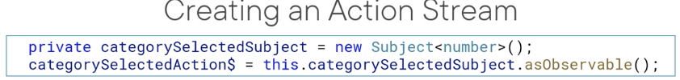

-Good practice to encapsulate the subject variable so it can’t be accessed from outside

-But we do want other parts to subscribe and react to its emission so define a read only (asObservable)

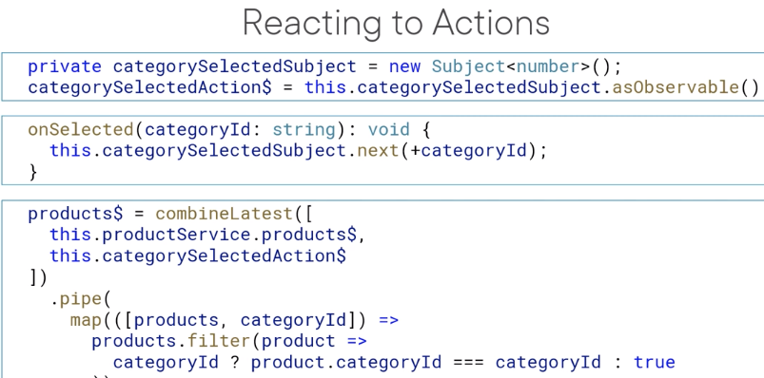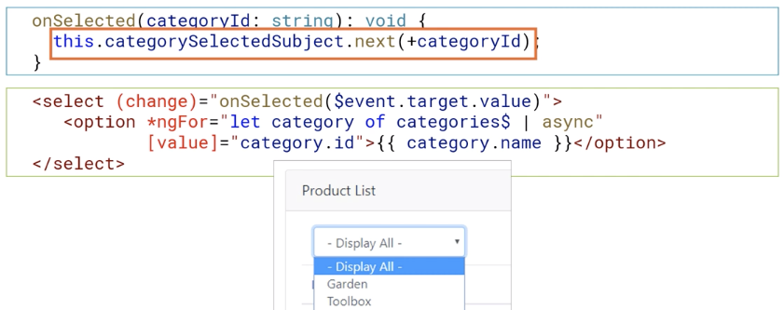

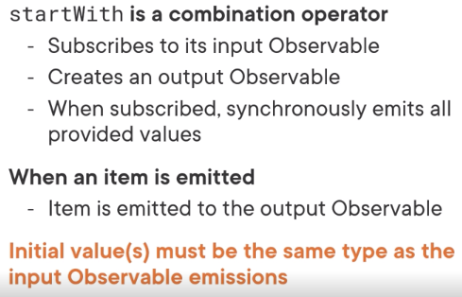

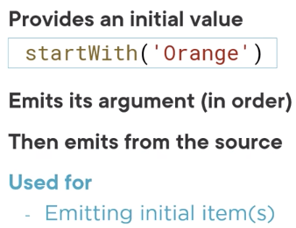

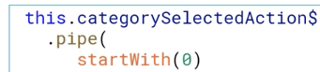



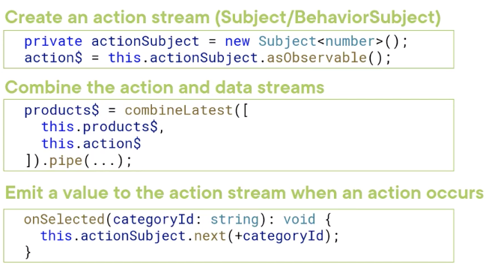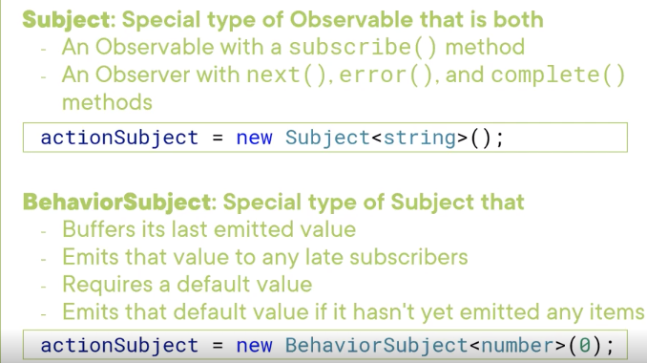

Reacting to Actions:

React to selections/errors, manage state with observables, react to add operations

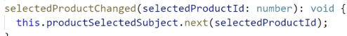

-emit it on the private Subject, that is why we creating the method on the service file



-use ngClass to set our styling

-put the safe navigation operator (?) because no id is selected at first

-Angular OnPush change detection only detects changes made to input properties and events from child components and Observables bound in the template using a async pipe

-Bound values set in local properties won’t trigger change detection, so won’t update the UI

State

-information about the view (loading indicator)

-user information that is tailored to the application to the user

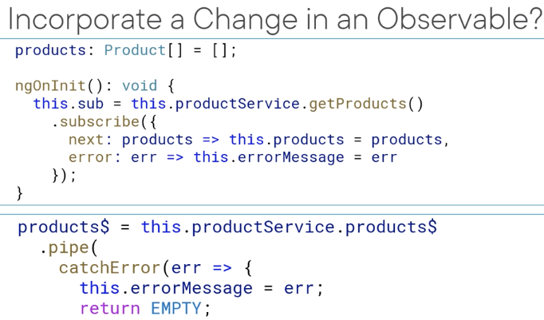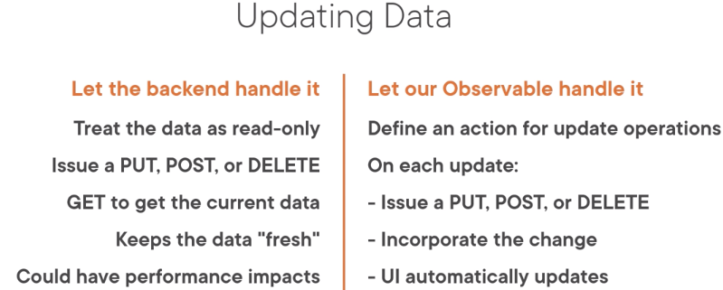-entity data, user selection and input

-Before reactive, we used an array and received notification that the data arrived from the back-end server, then assigned emitted products to that array. To add, update, delete we can simply edit the array

-But for observable, we have a data stream and we can’t emit new values into a data stream

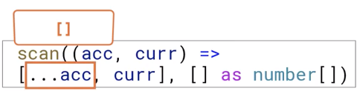

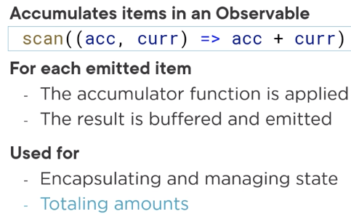

Scan: a key/transformation operator when managing states

-For an array, use spread to add on

-Seed, if defined, is used as the initial state otherwise the first emitted value is used

-Once initial state is set, next emitted items are accumulated by the function

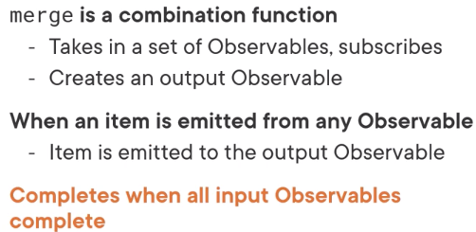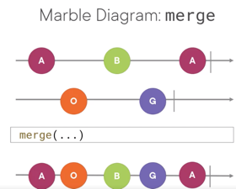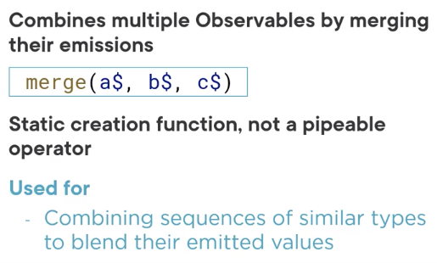

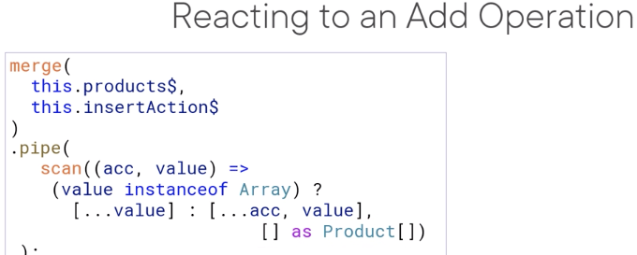

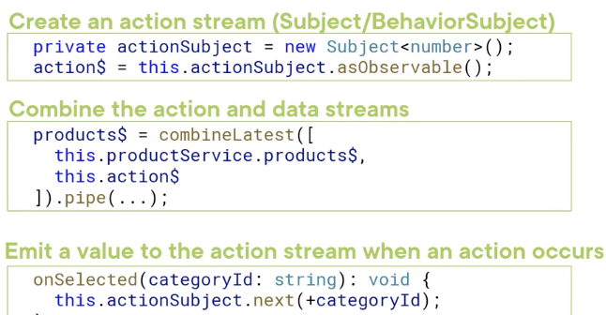-Seed is the initial state, when an item is emitted it will add to that seed

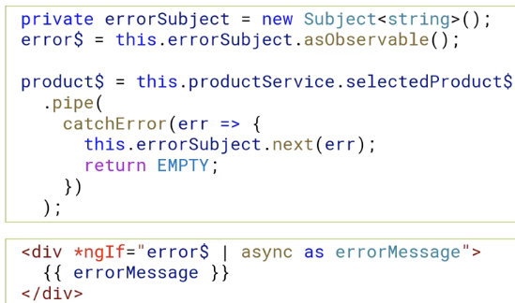

-We need to emit our errors instead of simply binding to an error string because we are using onPush change detection

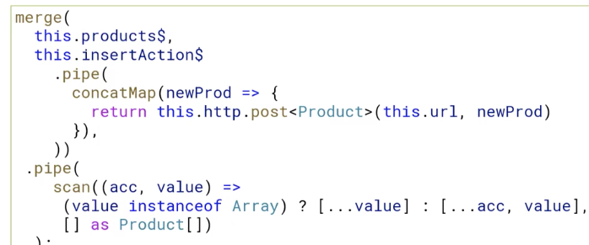

-Every time a new product is emitted in the action stream, the product is posted to the back-end server and the return product is piped through the scan

Caching Observables

-retain retrieved data locally, reuse previously retrieved data, stored in memory or external

-run time caching, so the cache data is gone when user exits the app

-shareReplay/share

Advantages

-Improves Responsiveness, reduces bandwidth, network consumption, backend server load, redundant computations

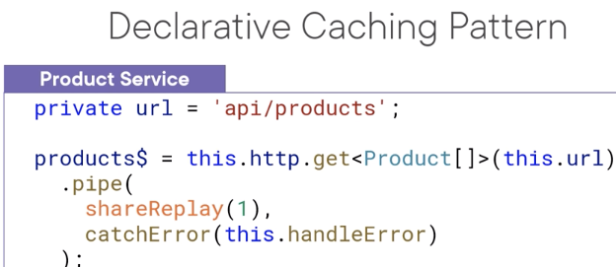

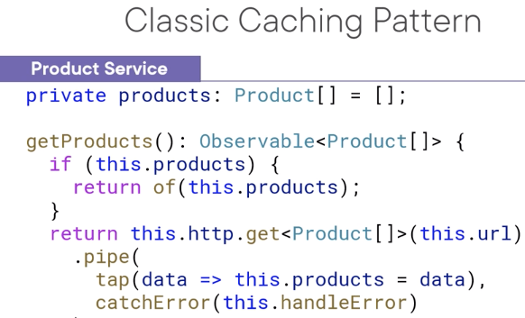

-Classic pattern is to define a property to hold the data but not very declarative

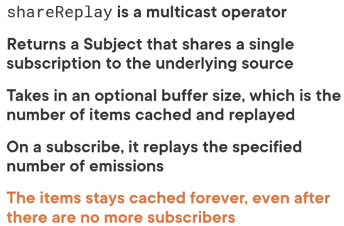

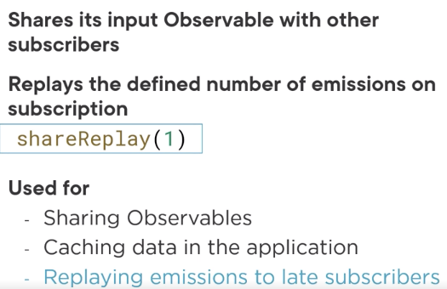

-Since data streams only emits one and completes, we normally specify 1 as the argument when using shareReplay while data caching

-Even if an observable completes, if another subscriber subscribes, the buffer is replayed

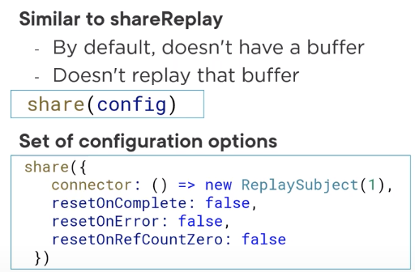

-Take in a configuration object

-You can control whether or not the share will replay and when the Observable should reset

-After reset, the next subscriber restarts the Observable

-Use it when you want more control

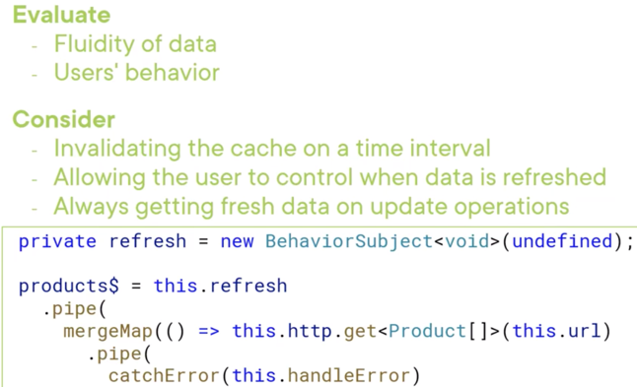-If the data doesn’t change often, caching is beneficial

-If the user exits often, you may not need addition features to invalidate the cahce

Higher-order Mapping operators

-An observable (Source/Outer) can emit anther Observable (Inner)

-So these operators will help flatten higher order observables

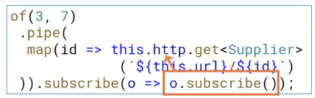-This is not recommended, how would we subscribe to the inner observable using aync pipe and how would we unsubscribe

-Also the return type would be Observable<Obervable<type>>, and we can’t bind to the template

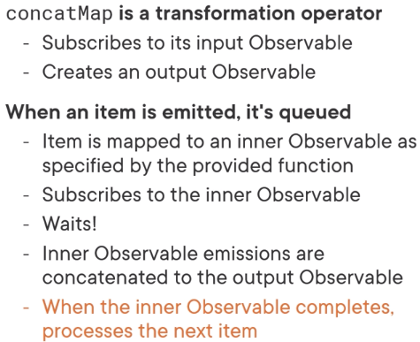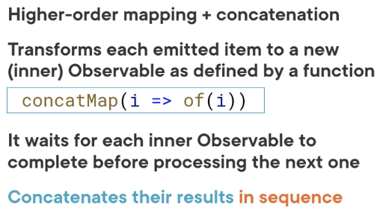 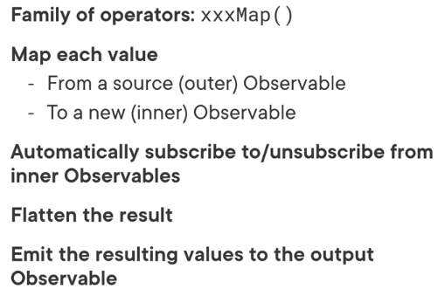

Think if concat as a relay, merge as a race (runners start concurrently then merge into lower lanes)

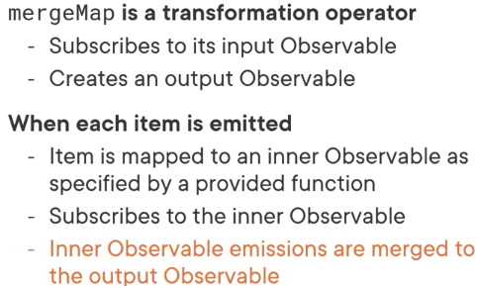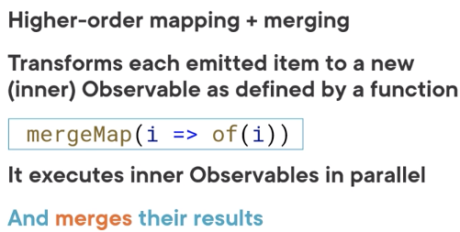

-if the first one takes longer, then it might emit later. The result is in no order

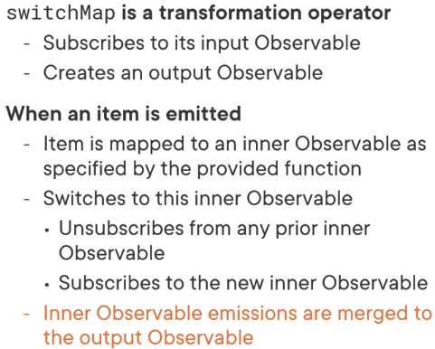-aka flatMap

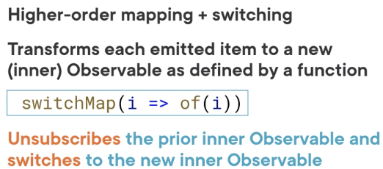

-It only subscribes to one inner observable at a time

-If any inner observable completes before the next emission occurs, then it will merge

-Think of it as a coach who changes their mind as to which runner will run

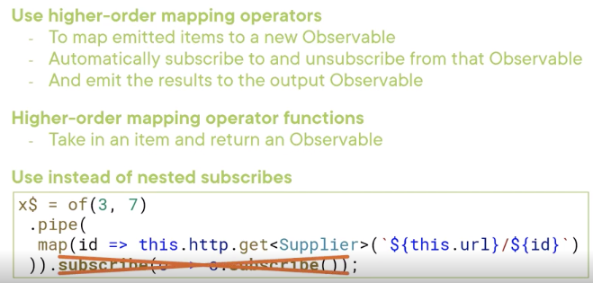-Examples: type ahead, auto completion, user selectin from a list

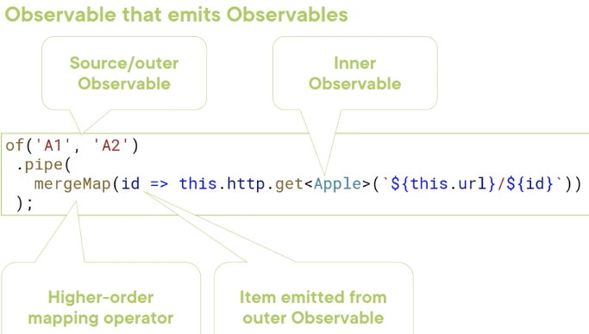

-Higher order mapping operator automatically subscribes and unsubscribes from the inner observable and flattens the result

-Flattening returns the value emitted from the inner observable

Combining All the Streams

Handling related data, creating ancillary streams, combining all streams

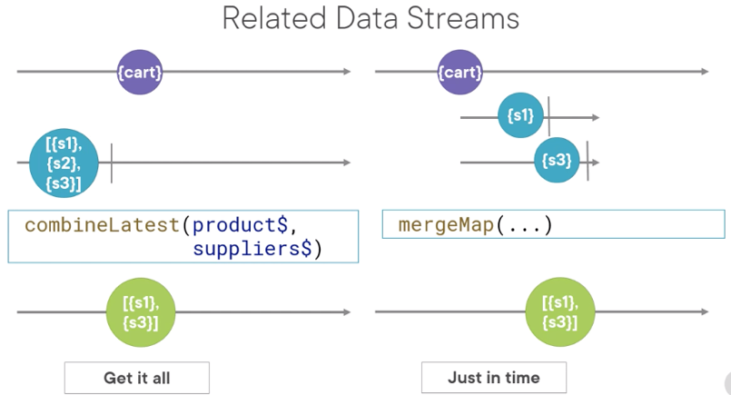

Get it all

-gets all the data from the related data sources as data streams and then finds the related items within those data streams as needed.

-use if dataset is reasonable size and doesn’t change often (cacheable)

Just in time

-Use the set of supplier IDs from the product, map each one to an observable, issue a GET request for each supplier ID, and merge them

-The output observable contains the suppliers for the selected product

-Use if dataset is large or if it changes too much

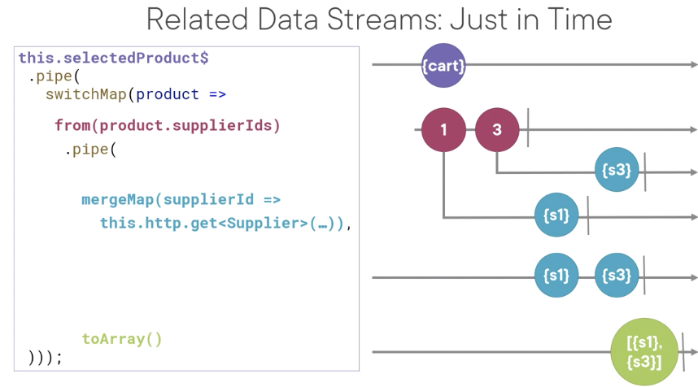

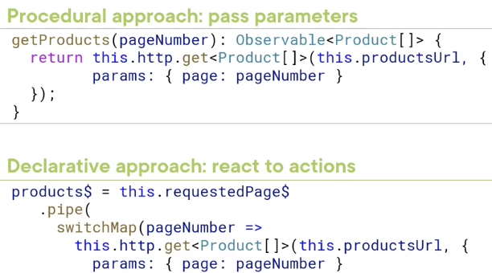

ngOnInit(): runs each time the page is initialized

when we subscribe to the observable, then the service issues HTTP request

http get returns an observable?

Note: we need the return keyword since we now have a multiline arrow function

Remove tracked files

git tm -r(?) --cached <file-name>

git add .

variable? //saying var | undefined

variable! //has a value other than null/undefined